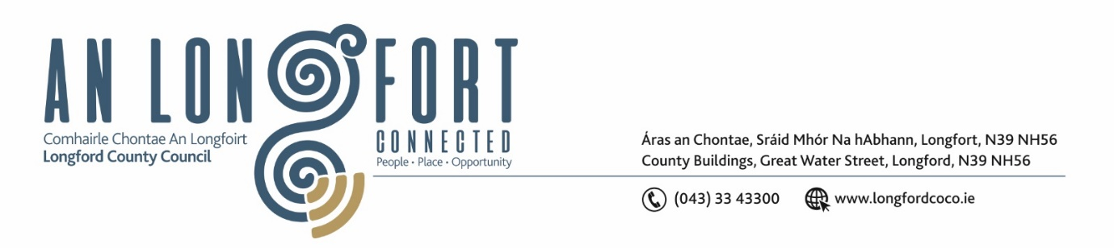

***Please note meeting will be held in the Council Chamber and via Microsoft Teams.***

13ú Deireadh Fómhair 2021.

**Chuig: Gach Ball don Chomhairle.**

A Chomhairleoir,

Iarrtar ort bheith i láthair ag Cruinniú Chomhairle Chontae Longfoirt a tionólfar i Seomra na Comhairle, Aras an Chontae, Longford agus via MS Teams are an **Dé Máirt, 19ú Deireadh Fómhair 2021 ag** **3.00pm** chun gnó a dhéanamh d’réir an Chláir thíos.

You are requested to attend a Meeting of Longford County Council to be held **in the Council Chamber, Aras an Chontae and** **via Microsoft Teams** on **Tuesday, 19th October 2021 at 3.00pm** to transact business, as set out on the Agenda hereunder.

Mise le meas,

*Ann Marie Mc Keon*

**__________________**

**Ann Marie Mc Keon**

**Meetings Administrator.**

**C L Á R**

Prayer before meeting.

**1.** Consideration of Chief Executive Report - Material Alterations Consultation phase and the Making and adoption of the Longford County Development Plan 2021-2027.